**Our software development services**

Combining tech expertise and industry-specific knowledge accumulated in the IT industry, Itransition develops custom software for medium-sized businesses and enterprises. Our offering includes full-cycle software development services, meeting our customers’ diverse business needs and technological objectives.

### Custom application development

Itransition builds custom solutions from scratch, ensuring their seamless integration with existing environments and systems.

### Platform-based product customization

With profound knowledge of tech platforms and components, we create software with an optimal set of out-of-the-box and custom features.

### Legacy application redesign

We redesign outdated systems, refactor their code, migrate legacy apps to newer platforms, and review their architectures to give them a new lease life.

## Driving business transformation

We deliver software solutions that improve enterprises’ productivity, strengthen their relationships with customers, and increase users’ loyalty, along with streamlining partnerships and team collaboration.

Internet of things

Proficient in enterprise, industrial and consumer IoT, Itransition provides IoT architecture design, backend engineering, platform development, and analytics configuration to help companies harness the power of connected devices.

#### Application services

We provide end-to-end application services, including custom and platform-based development, modernization, integration, security provision, and more, to help SMBs and enterprises capitalize on digitized workflows and customer experiences.

#### 

#### 

#### 

#### 

#### 

#### 

### Why customers love working with us

“The feedback on the product has been great. Users can quickly get information they need.  
It’s intuitive and easy for them to find the right Hockey stats.”

“I’ve really got to give credit to the teams that are working with us, YLR infotech is not only a backbone to our team, it is a backbone to our business.  
We can better manage business because of YLR infotech.”

“YLR infotech has become a trusted partner as we push the edge of innovation for connected charging platform.  
Their proven technical competency and delivery track record made them our partner of choice..

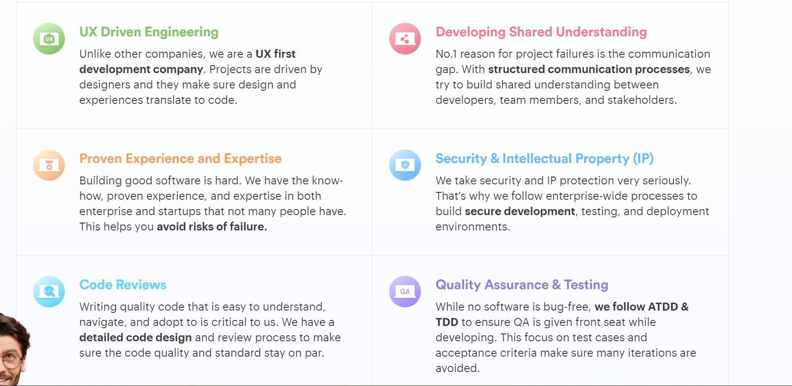

Based on the needs of our clients, we can support them in end-to-end product development or seamlessly extend their in-house team of engineers.

* Web app development
* Mobile app development
* Product design
* Software development

Over 80% of our customers return to us for help with new digital products. We support them at every stage of software prYou are welcome to fill in the form below, and our IT experts will reach out to you during business hours to discuss your project.elopment.

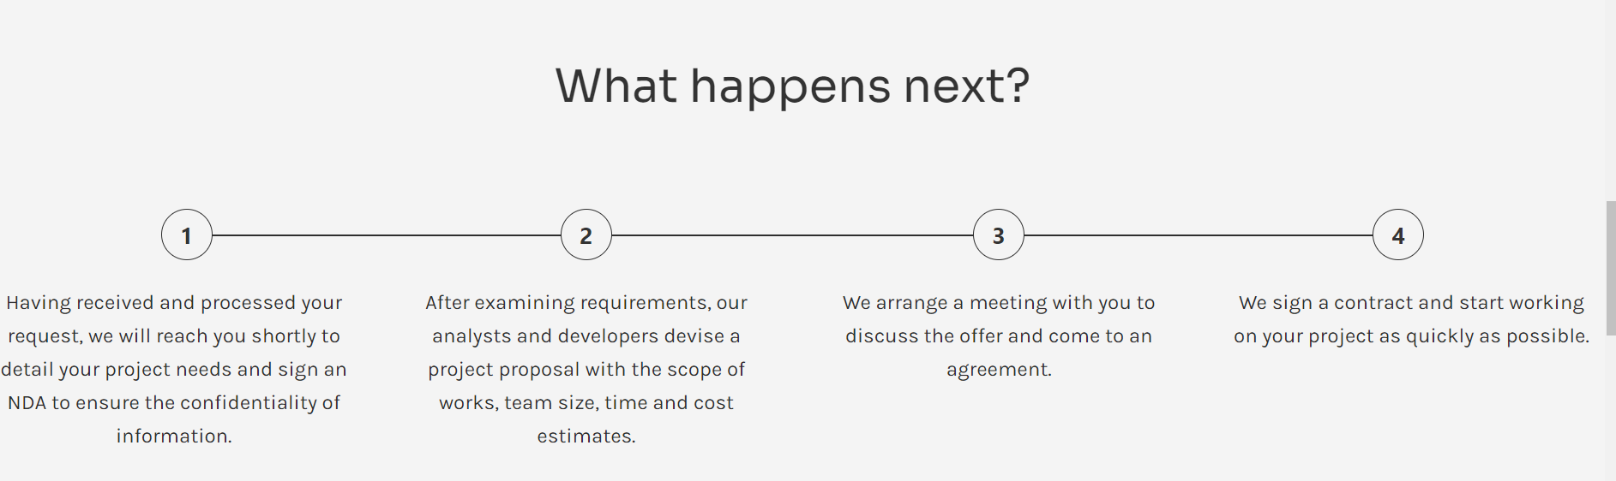

* CUSTOM SOFTWARE DEVELOPMENT

As a software engineering company, we turn your ideas into innovative and reliable products. Tailored to particular business needs, custom solutions designed by Innowise Group help enhance market competitiveness, streamline business processes, and simplify enterprise management.

* DEDICATED TEAM
* IT CONSULTING & SUPPORT
* DIGITAL TRANSFORMATION

### **Web**

We develop and implement custom web-based solutions tailored to particular business and technological requirements. Innowise Group offers web application development services bringing in vast technology and industry expertise

### **Mobile**

Top-notch iOS & Android mobile apps based on the latest technologies and global trends

### **Desktop**

High-quality desktop applications that meet particular business and technical requirements

* YLR infotech Group can cover the entire software development process, from product vision discussion to applications design and software enhancement. Our multi-skilled experienced team facilitates businesses worldwide on their way to digital transformation and helps companies take full advantage of IT innovations. Whether you need custom software development or IT staff augmentation, we are ready to help you at any stage of the project.

